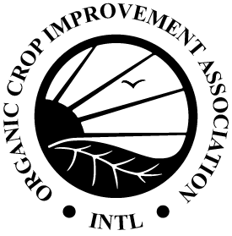
Ammonia Level Monitoring Form (COR)

6.7.1(f) Producers must monitor ammonia levels to ensure good air quality to maintain ammonia levels below 20 ppm. When ammonia levels exceed 20 ppm, producers must implement additional practices to reduce ammonia levels below 20 ppm. Ammonia levels must not exceed 25 ppm. In addition, air quality shall be managed according to the Code of Practice for the type of livestock in question (see 2.4)

Date | Testing Method | Ammonia Level | Actions Taken
Date | Testing Method | Ammonia Level | Actions Taken

