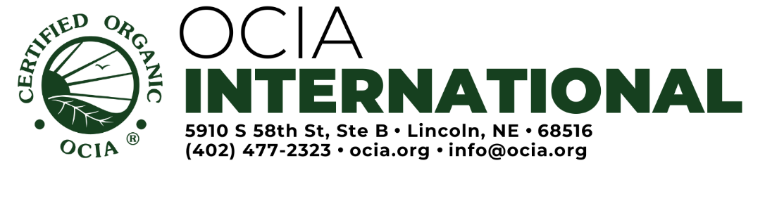
INSPECTOR APPLICATION
Type or print all information legibly.
Name: |  | Cell Phone:
Mailing Address: |  | Alternate Phone:
E-mail: |  | Fax:
Please include the following documents along with this application for OCIA inspector approval:
Resume/curriculum vitae - please indicate in some way that your experience includes 2,000 hours or approximately one year of full-time equivalent experience
List of Trainings (along with dates & certificates), if not included on your Resume or CV. (IOIA, NOP, COR, EU, JAS, etc.)
Copies of certificates for completed training and schooling
Inspection Report Samples for each scope requested
Professional License (LPO only)
OCIA Forms:
OCIA Inspector Work Agreement
Inspector Information Form
Conflict of Interest Annual Declaration
Electronic Signature Form
Confidentiality Form
CÓDIGO DE ÉTICA Y CONDUCTA PARA LOS ÓRGANOS DE COADYUVANCIA (LPO only)

For what types of inspections do you seek OCIA approval?
Farm Wild Crops Livestock Processing/Handling Brokers Maple Syrup
Apiary Shade-grown Coffee Community Grower Groups (CGGs)
Other (e.g. Bird Friendly):

Section 1: Inspection Experience, Language, and Availability
1 | Are you currently an organic inspector? Yes No
2 | List the names of all the certification agencies for which you have inspected:
3 | Date of Last Witness Evaluation:  Certifying Body who completed the evaluation:
4 | Do you consider yourself a full- or part-time inspector?
4 | For how many years have you been inspecting? Farm Processing/Handling Livestock  Apiary Maple Syrup Community Grower Groups (CGGs) Other (specify):
4 | How many inspections do you average per year? Farm Processing/Handling Livestock  Apiary Maple Syrup Community Grower Groups (CGGs) Other (specify):
4 | How many inspections have you completed? Farm Processing/Handling Livestock  Apiary Maple Syrup Community Grower Groups (CGGs) Other (specify):
4 | How long have you been involved in the organic industry? Years
5 | Please detail your inspection experience with the following scopes. Distinguish inspection expertise with a * symbol (i.e., Dairy*, Aquaculture*, Investigations*, etc.)  Farm:  Processing/Handling:  Livestock:  Apiary:  Maple Syrup:  Community Grower Groups (CGGs):  Other (specify):
6 | In addition to noting your native language(s), please cite other language skills:
6 | Fluent:
6 | Written:
6 | Conversational:
7 | List the professional organizations of which you are a member:
8 | Has disciplinary action been taken against you as an inspector? No Yes (please explain):
9 | Define factors that may limit your ability to inspect for OCIA:

Section 2: Experience
New inspectors must be able to demonstrate a Minimum 2,000 hours (1 year) of relevant experience (eligible experience includes but is not limited to; work on a farm or ranch, agricultural extension work, agricultural education, internships, apprenticeships, experiential education, 4-H, FFA, other inspecting/auditing work, management of organic food handling operation, food processing research, natural resource management work).
Experience | Check all that apply | Hours/Years | Comments  Please provide some more detailed comments about the experience (Name of University, type of farm/company, etc.)
CROPS and WILD HARVEST and MAPLE SYRUP (including grower groups)
College/University in Agriculture or related field
Working experience in the field of agriculture (working with a company with crop production)
Non-Organic auditor experience (other agricultural schemes, e.g. Global GAP, RSPO, Rainforest Alliance, etc…)
Certifier experience, working in organic certification other than auditing
Other
PROCESSING / HANDLING
College/University in Food Industry or related field
Working experience on the field of Food Industry (working with a company with food processing)
Non Organic auditor experience (other , e.g. Global GAP, Food Safety, etc…)
Certifier experience, working in organic certification other than auditing
Other
LIVESTOCK and APIARY (including grower groups)
College/University in Livestock/Agriculture or related field
Working experience on the field of Livestock (working with a company with LIVESTOCK)
Non-Organic auditor experience (other programs , e.g. RDS; RWS; Animal welfare, etc...)
Certifier experience, work in organic certification other than auditing
Other

Personal Comments

The information supplied in this application is complete and accurate to the best of my knowledge. I realize that providing knowingly incomplete or false information is reason for removal from the OCIA-Approved Inspector List. Furthermore, I realize that OCIA approval does not guarantee future OCIA inspection work.

Signature: Date:

