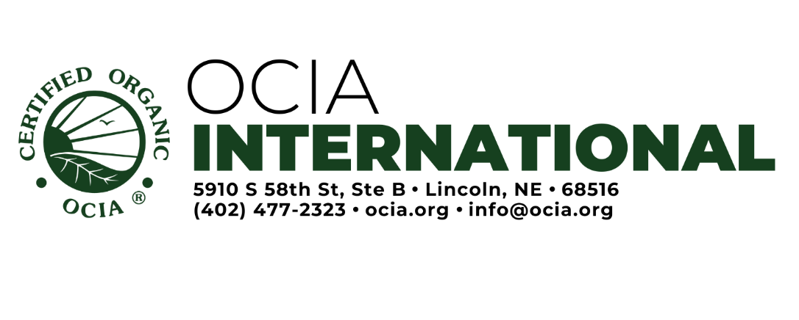
Reinstatement Information Form
Instructions: This form is to be completed by the suspended operation to provide OCIA with the operation’s corrections to the noncompliances that led to suspension, the operation’s plans to prevent the same noncompliances in the future, and the operation’s plan to sell any products/crops produced prior to reinstatement (if granted) as conventional.

Date:
Operation Name: | Operation Number#:

Were you suspended by another Certification Body?
YES NO If YES, indicate the other certification agency:

Is your operation requesting reinstatement prior to the conclusion of the suspension period?
YES NO If YES, please explain:

A. Noncompliances
Please list all noncompliances that led to the suspension of the operation (this information can be found on the Notice of Proposed Suspension letter), along with how you have fixed the noncompliances. Please also indicate your plan (i.e., corrective action plan) to prevent these same noncompliances from occurring in the future. This will be verified at inspection. Please provide supporting attachments or additional sheets as needed.

Noncompliance (summary of the noncompliance that led to suspension) | How have you fixed this noncompliance? | What is your plan to prevent it from occurring again in the future?

B. Previous Inventory and Products/Crops Produced Prior to Suspension
Any previously certified organic products or crops that were produced prior to suspension, along with any products/crops produced and harvested prior to reinstatement, must be sold as conventional. Only crops harvested after reinstatement and products produced after reinstatement (if granted) may be sold as “organic.” Please complete the below questions to detail how products/crops produced prior to suspension will be segregated.

1. Does your operation have any products or crops in inventory from prior to suspension that were previously certified organic?

YES NO If NO, please continue to section C (crop production) or D (handling/processing).

2. Please explain your plan to sell previously certified product or crop (now “non-organic” due to suspension) as conventional/non-organic, including how the non-organic product/crop will be kept segregated if reinstated:

C. Crop Production Only: Products/Crops Produced During the Suspension Period
All crops harvested during the suspension period must be sold conventionally (i.e., as “non-organic”), and any products produced during the suspension period must be labeled as sold as “non-organic.”

1. Does your operation have any current year inventory?

2. When do you expect to harvest? N/A, growing crops

3. Please explain your plan to sell crops harvested prior to reinstatement conventionally (i.e., as “non-organic”), including how the non-organic crop will be kept segregated if reinstated: N/A, growing crops

D. Handling Operations only: Products/Processed products produced or purchased during the Suspension Period

1. For processing/handling operations, does your operation have any inventory of products produced or purchased during the suspension period?

2. For processing/handling operations, please explain your plan to segregate the inventory of existing products produced or purchased during the suspension period

