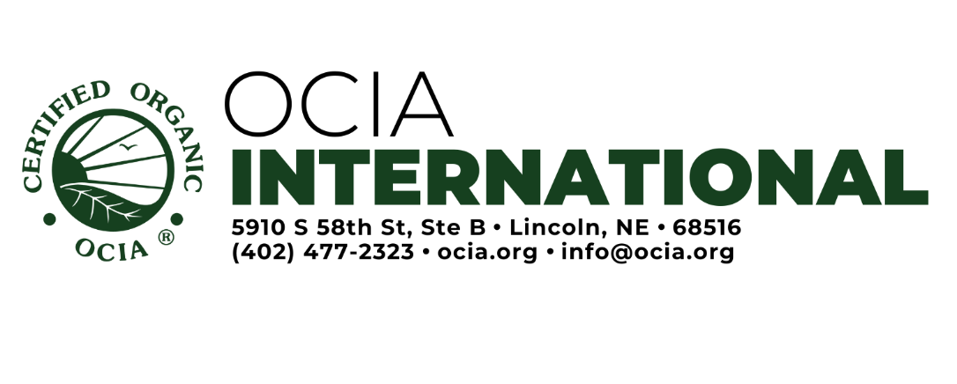

Operator Corrective Action Plan

Guidance: The first step to fixing a noncompliance is to ask what caused the noncompliance to occur. Answering this question will help get to the root of the problem to ensure the correction will prevent the noncompliance from happening again. After that, the operation can correct the noncompliance and create a corrective action plan.

Instructions: Major Noncompliances require submission of a corrective action plan along with objective evidence to show the noncompliance has been resolved and how the operation will prevent recurrence in the future. This form can be utilized to assist operations in documenting their response to noncompliances along with the corrective action plan for the future.

To resolve a noncompliance with OCIA, the operation must:
A) Explain how the noncompliance was corrected and provide objective evidence to support the explanation, attaching supporting documentation as needed.
B) Provide an actionable plan explaining how the operation will ensure the noncompliance does not occur again. OCIA will follow up to ensure that the plan was effective.

Example Issue: Not responding to minor noncompliances due by a certain date, so a Major Noncompliance was issued.
An operator response to the noncompliance could look like this:
A) All minor noncompliances were reviewed and updates were made to the OSP and field history. OMRI certificate was obtained for input.
The updated C2.0 and C5.0 are attached, along with the revised field history and ABC OMRI certificate.
B) The minor noncompliances were issued on a Corrective Action report, which was sent with my organic certificate. Since I hadn’t made a sale for the season yet, I didn’t open the envelope. To prevent this in the future, I will open mail from OCIA at least once a week on Sunday afternoon. I have set a reminder on my phone. I will set up any further reminders on my phone if I need to follow-up on any requests from OCIA.

Note: if this is being supplied in response to a Notice of Denial or Notice of Proposed Suspension, it is necessary to also request mediation.

Operator Corrective Action Plan

Date of Letter from OCIA:
Name of Letter from OCIA (e.g. Notice of Noncompliance):

A) Please explain how the noncompliance(s) indicated in the Notice were corrected and provide objective evidence to show how the noncompliance was resolved. Attach documents as needed and explain how the documents indicate correction of the noncompliance: Feel free to attach additional sheets as needed:

_________

B) Describe your plans to ensure the noncompliance does not occur again and any changes you have made to your operation:

Signature of Operator: Date:

Operation Name: Operation Number:

