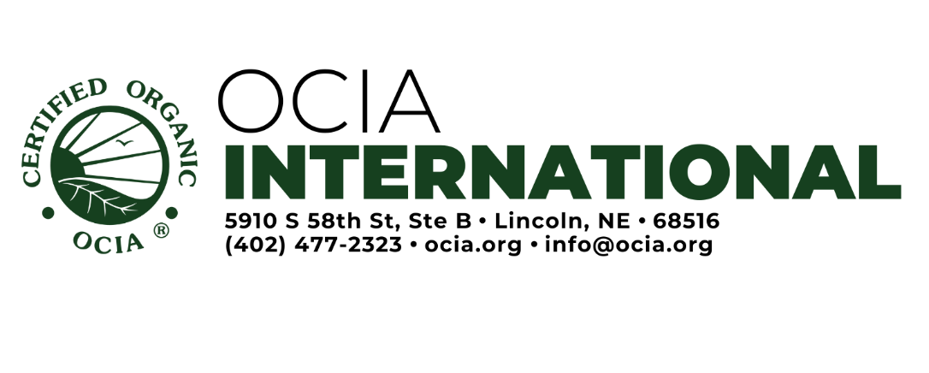
Livestock Feeding Record
Use this form to record actual feed rations fed on each date to each type and class of livestock throughout the year.
Type and Class of Livestock: Number of Animals: Year:

Date or Date Range: | Feed(s) & Amount of each: | Source & Storage ID

Please have documentation for inspection to support the information recorded above, including the following (as applies): feed-production/feed-storage records, purchase invoices (bills of lading, weigh tags, etc), current organic certificates for all purchased feed, and labels of feed additives and feed supplements.

