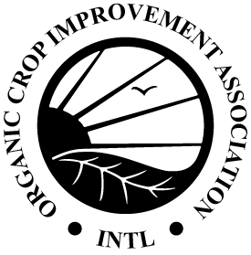
Ammonia Level Monitoring Form

205.241(b)(2) Producers must monitor ammonia levels at least weekly by taking measurements at the height of the birds' heads and implement practices to maintain ammonia levels below 20 ppm. When ammonia levels exceed 20 ppm, producers must implement additional practices and additional monitoring to reduce ammonia levels below 20 ppm. Ammonia levels must not exceed 25 ppm.
Many types of ammonia monitors are readily available for poultry producers. Your state extension office, state environmental offices, or other on-line services can be contacted for further information on monitoring equipment and practices.

Date | Testing Method | Ammonia Level | Actions Taken
Date | Testing Method | Ammonia Level | Actions Taken

