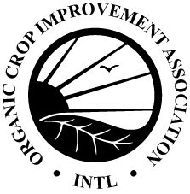
COR Organic Processing Notification Form

Please provide this completed form to notify OCIA that your operation will begin production of organic products. OCIA will review the form and supplied documentation. Once approved, OCIA will issue an organic certification and addendum that lists the approved organic products. Please note that only organic products listed on the product addendum are certified organic and can be sold as “organic.” Please note that additional verification, such as additional inspections or audit trail documentation, may be required to verify compliance with COR.
Operation Name:
Operator #:
Date:
Section A: Processing Notification
1. When did your operation start handling organic products?
Please note products cannot be sold as “organic” until an organic certificate is issued.

2. Did your operation previously submit labels and Organic Product Ingredient (OPI) sheets to OCIA with your application? Yes No
If NO, please skip to Section B.

3. If YES on #2, have the labels and/or OPIs been revised since they were submitted to OCIA? Yes No
If NO, this form is complete and can be submitted to OCIA.

4. If labels or OPIs have been revised, please provide the following documentation (as applies) with this form:

All Revised Organic Product Ingredient sheets
All Revised labels
As applicable: Updated (C)H3.0 Ingredients, if ingredients to be disclosed have changed.
As applicable: Complete documentation for new non-agricultural ingredients and processing aids
As applicable: Product specification sheets for new ingredients

5. Will your operation be immediately producing any new products (i.e., not previously submitted to OCIA)?
Yes No
If YES, please also complete Section B.
Section B: New Product Submission
To submit new products for review, please provide the following completed forms along with all supporting documents requested on the forms.
Additional Processed Product/Production Line/Program Affidavit
New Product Submission Checklist

