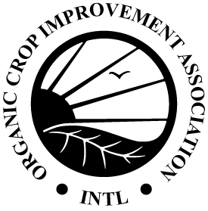
OCIA International, Inc.
1340 N. Cotner Blvd. | Lincoln, NE 68505 | USA
Phone: 402.477.2323 | Fax: 402.477.4325
info@ocia.org | www.ocia.org

EU (EC) or UK Seed Exemption Request

We are requesting prior authorization to use non-organic seed or vegetative propagated material for crops to be certified to EU or UK Equivalency, because the type and variety of seed and/or vegetative propagated material we want to use is not commercially available on the market as organic. We understand the seed exemption can only be granted for one growing season, must be obtained before planting the crop, and must be requested again if non-organic seed/vegetative propagated material is requested for use in a future season. I understand that non-organic seedlings for annual crops cannot be authorized.

- Common Name (type) and variety of seed/vegetative material:
- Scientific Name (Latin name) of seed/vegetative material:
- Quantity of Seed/vegetative material (by weight or number of plants):

- Is this seed/material verified as non-GMO?
- Is this seed/material available as organic or in-conversion?

- Reason exemption is requested (see standard below):

- Origin (provider):

- Does a different program from EU certify the seed/vegetative materials as organic?
Attached with request:
Seed Search with specific companies contacted
Other documentation to show seed isn’t commercially available (catalog, brochure, etc)
Documentation showing that seed/vegetative material is from a non-GMO source
Documentation showing any seed treatments for the seed/vegetative material.
Other (tags, purchase orders, organic certificate, etc):

Signature of Operator: Date:

Operation Name: Operation Number:

IACB Equivalent European Union Organic Production & Processing Standard for Third Countries 6.4.2 (5):
Authorization to use seed or seed potatoes not obtained by the organic production method may only be granted in the following cases:
(a) where no supplier, meaning an operator who markets seed or seed potatoes to other operators, is able to deliver the seed or seed potatoes before sowing or planting in situations where the user has ordered the seed or seed potatoes in reasonable time;
(b) where the user is able to demonstrate that the desired variety and none of the registered alternatives of the same species are appropriate and that the authorization therefore is significant for her/his production;
(c) where it is justified for use in research, test in small-scale field trials, or for variety of conservation purposes agreed by the control body.

CDT Decision: Verified Compliant Not Compliant
CDT Comments:

CDT Member: | Date (M/D/Y):

