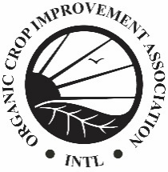 | Template Letter to Notify Applicators. Header can be updated with your contact information (i.e. operator or consultant). Click on this text to edit.

Date

Attention Commercial, Noncommercial and Private Applicators:

This is a notice informing you that we operate certified organic farm ground in your area under the regulations of the USDA, National Organic Program (“NOP) 7 CFR § 205.

Any contamination of certified organic farm ground due to drift, over spray, or runoff is a violation of the NOP. Over spray and/or runoff may cause our farm ground to be decertified from organic production and may prohibit us from marketing under the NOP certification for three years. These actions will lead to a substantial loss in income and other damage. We are required by the NOP to immediately notify our certifying agent of any application, including drift, of a prohibited substance to any of our fields (7 CFR § 205.400(f)(1)). In addition, we are inspected annually by an organic inspector and any suspected contamination is documented and will be reported to the <indicate your state agency here. E.g. Iowa Department of Agriculture & Land Stewardship, Pesticide Bureau>.

If you will be working on land adjoining organic land, please take precautions to prevent over spray, drift, or runoff. <Indicate any additional information, such as pesticide-sensitive crop registry websites. Double-check that the links are valid.> We would like to thank you for your cooperation in the past and thank you for your future cooperation. If you would like additional information about our organic practices please contact us at <your phone number>.

Location of our organic fields:

County Plat Map Coordinates

Sincerely,

<signature>

<Name>
<Name of operation>

