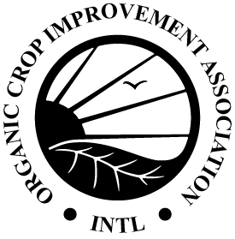
OCIA International, Inc.
1340 N. Cotner Blvd. | Lincoln, NE 68505 | USA
Phone: 402.477.2323 | Fax: 402.477.4325
info@ocia.org | www.ocia.org

Pasture Rotation/Grazing Schedule/Animal Movement Record
Use this form to track the movement of animals and pastures grazed.
Location | Pasture/Paddock | # Head | Livestock Type/Class | Begin Date | End Date

