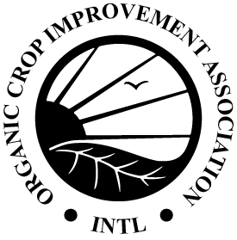
OCIA International, Inc.
1340 N. Cotner Blvd. | Lincoln, NE 68505 | USA
Phone: 402.477.2323 | Fax: 402.477.4325
info@ocia.org | www.ocia.org

Livestock Feeding Record
Use this form to record actual feed rations fed on each date to each type and class of livestock throughout the year.
Type and Class of Livestock: Number of Animals: Year:

Date or Date Range: | Feed(s) & Amount of each: | Source & Storage ID

Please have documentation for inspection to support the information recorded above, including the following (as applies): feed-production/feed-storage records, purchase invoices (bills of lading, weigh tags, etc), current organic certificates for all purchased feed, and labels of feed additives and feed supplements.

